ASSIGNMENT LAB 5
QUESTION N0 01: (CODE)
#include<iostream>
using namespace std;
int main(){
int a,b;

cout<<"Enter a number to print its table.\n";
cin>>a;
for(b=1; b<=10; ++b){

cout<<a<<"*"<<b<<"="<<a*b<<endl;}
return 0;
}
QUESTION N0 01: (OUTPUT)
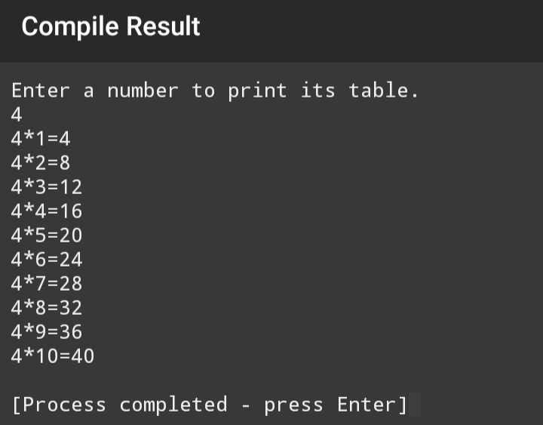
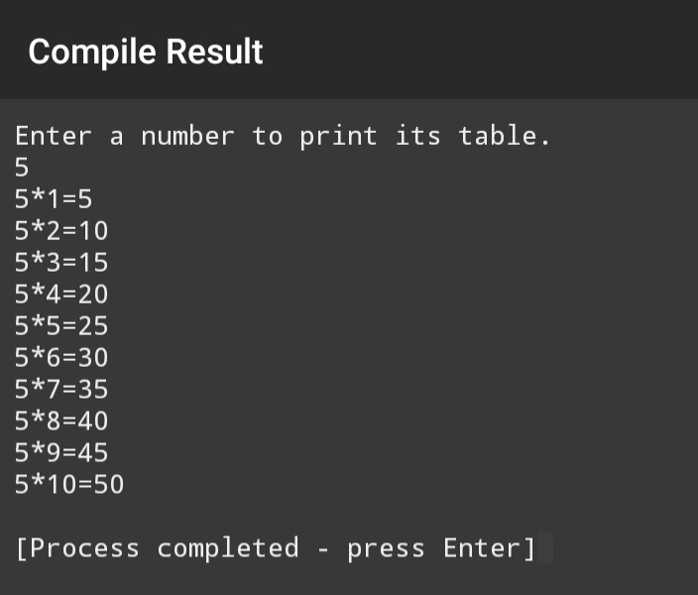
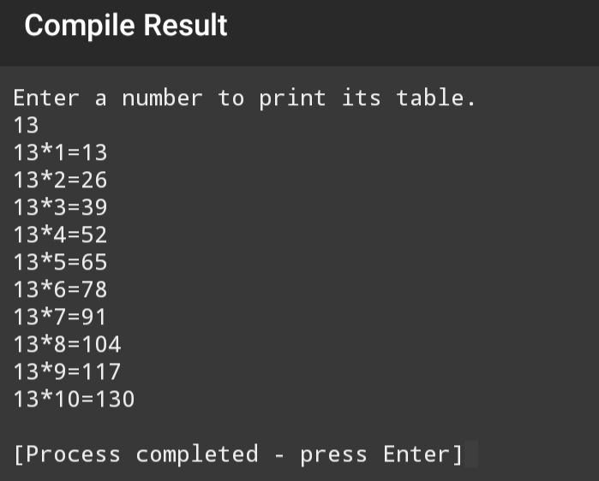
QUESTION N0 02: (CODE)
#include<iostream>
using namespace std;
int main(){
int range,a;
cout<<"Enter the range upto which the loop should run\n";
cin>>range;
for(a=1; a<=range;++a){
cout<<a;
if(a%2==0){
cout<<" is even\n"; }
else {
cout<<" is odd\n"; }
} return 0;
}
QUESTION N0 02: (OUTPUT)
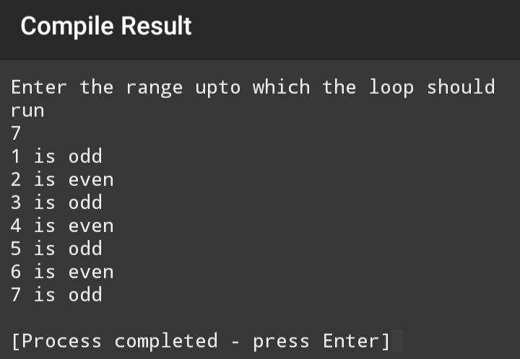
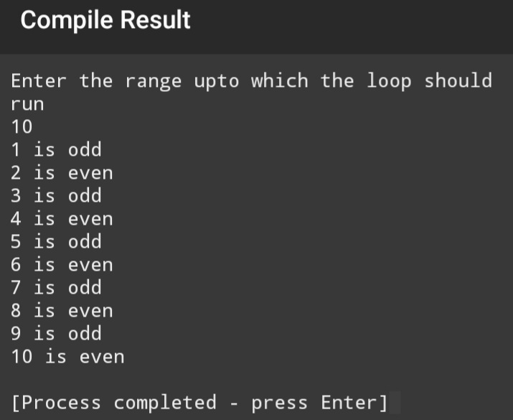
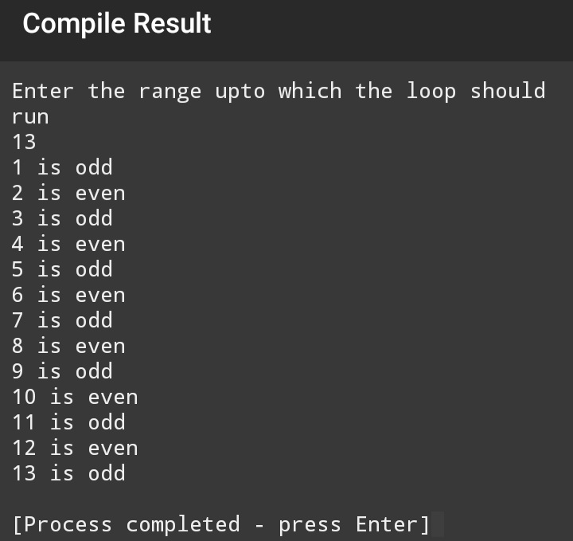
QUESTION N0 03: (CODE)
#include<iostream>
using namespace std;
int main(){
int range,a;
cout<<"Enter the range upto which the loop should run:";
cin>>range;
for(a=0; a<=range;++a){
if(a%2==0)
cout<<a<<endl;
}
return 0; }

QUESTION N0 03: (OUTPUT)
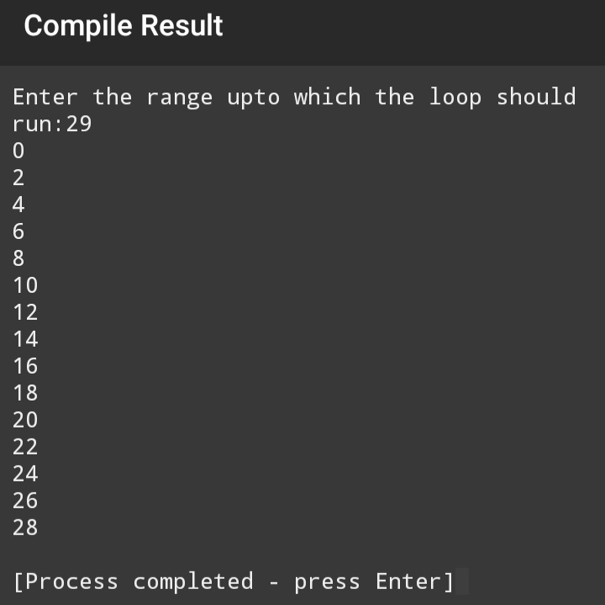
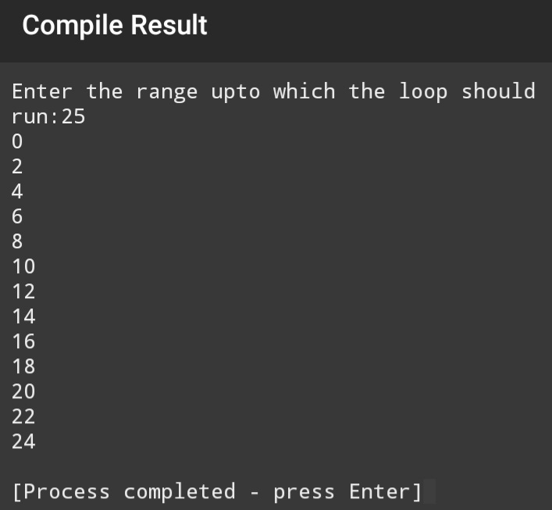
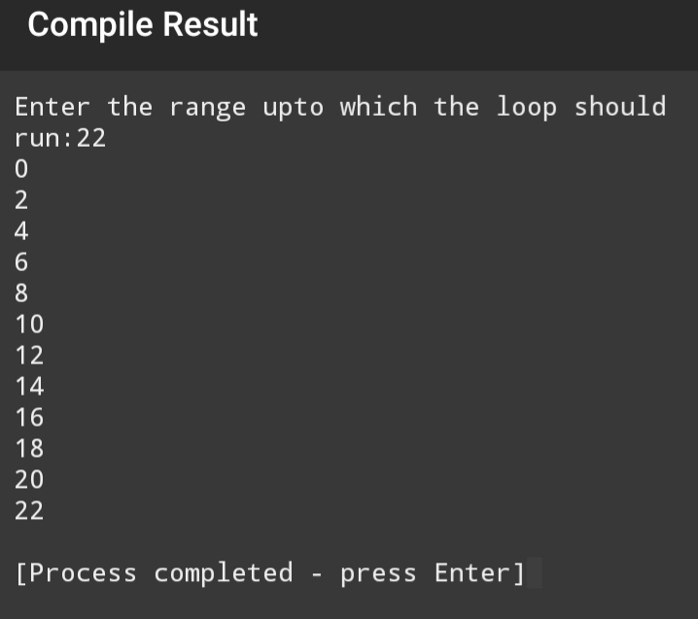
QUESTION N0 04: (CODE)
#include<iostream>
using namespace std;
int main(){
int range,a;
cout<<"Enter the range upto which the loop should run:";
cin>>range;
for(a=0; a<=range;++a){

if(a/5&&a%5==0)
cout<<a<<endl;
}
return 0; }
QUESTION N0 04: (OUTPUT)
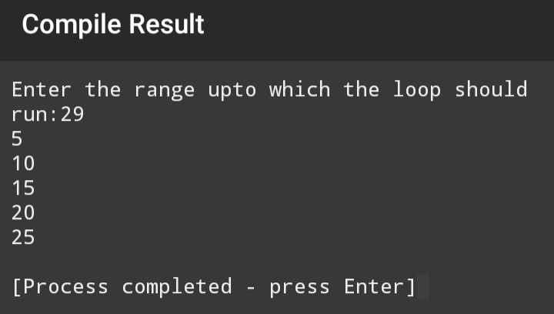
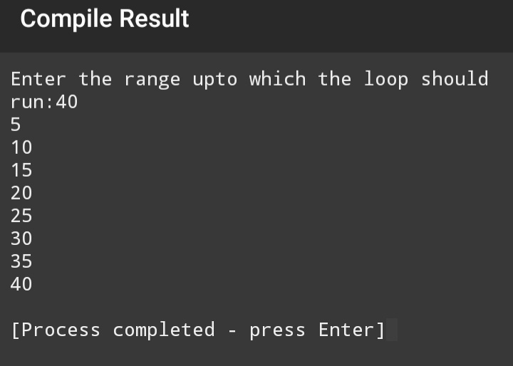

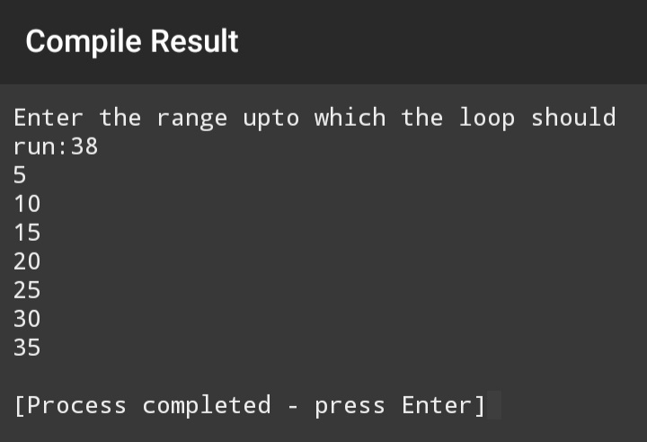
QUESTION N0 05: (CODE)
#include<iostream>
using namespace std;

int main()
{
int a=1;
int b=2;
for(a=1; a<=55; a=a+b++)
cout <<a<<" ";
return 0;
}

QUESTION N0 05: (OUTPUT)

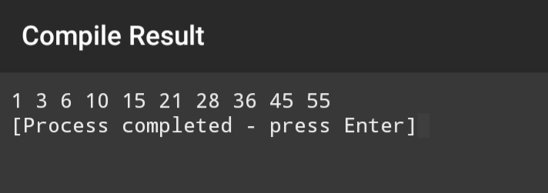
QUESTION N0 06: (CODE)
#include<iostream>
using namespace std;

int main()
{
int x(1),sum(0);

while ( x>=0)
{
cout << "Enter any integer number: \n";
cin>>x;
if(x>0 && x<=30){
sum=sum+x;
}
else if(x>30){
cout<<"This number is greater than 30 and won't be calculated.\n";
}

x++;}
cout<<"The sum is "<<sum<<endl;
return 0;
}
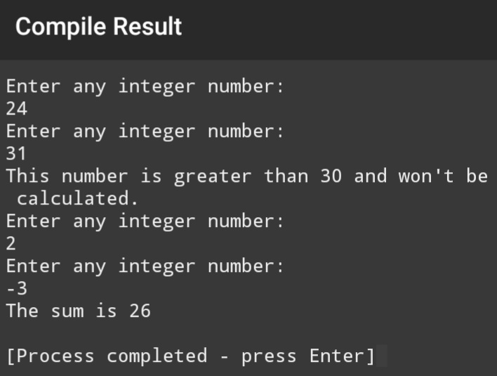
QUESTION N0 06: (OUTPUT)

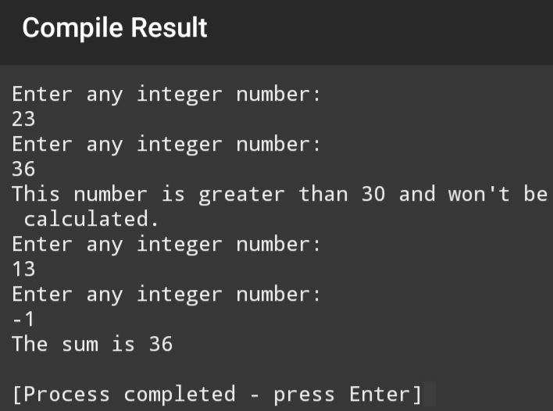

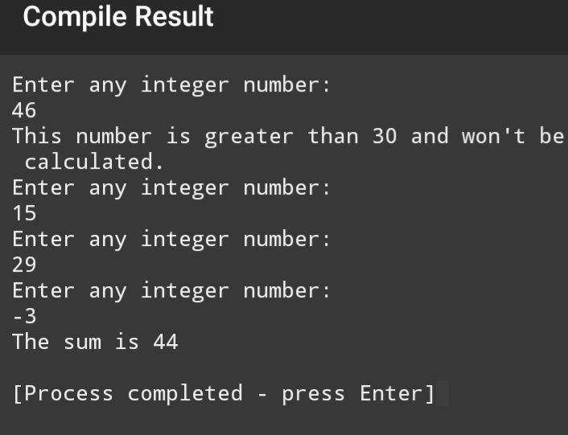

QUESTION N0 07: (CODE)
#include<iostream>
using namespace std;

int main()
{
int x,y,next_term;
x=0;
y=1;

cout <<x<<", "<<y<<", ";
for(next_term=1; next_term<=22; next_term++){

next_term=x+y;
x=y;
y=next_term;
cout <<next_term<<", ";
}
return 0;
}

QUESTION N0 07: (OUTPUT)
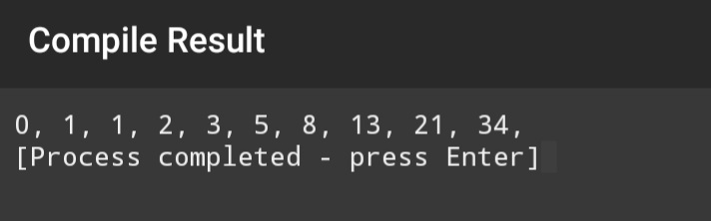

QUESTION N0 08: (CODE)
#include<iostream>
using namespace std;

int main()
{
int a(0),x(0),y(0),b;

for ( b=1; b>0; b++)
{

cout<<"1. Books (per item price = 500)\n"
<<"2. T-Shirt (per item price = 700)\n"
<<"3. Shoes (per pair price = 1000)\n"
<<"0. Exit the program\n";
cout << "Enter any number to select any product to buy or 0 to exit: ";
cin>>b;
if(b==1){
cout<<"You have selected books. "<<"Enter quantity: ";
cin>>a;
}
else if(b==2){
cout<<"You have selected T-shirt. "<<"Enter quantity: ";
cin>>x;
}
else if(b==3){
cout<<"You have selected shoes. "<<"Enter quantity: ";
cin>>y;
}
else if(b==0){
cout<<"Exit the program.\n ";
b=-1;
}
}
cout<<"*****Receipt*****"<<endl;
cout<<"You have bought "<<a<<" books (price = "
<<a*500<<")"<<endl;
cout<<"You have bought "<<x<<" T-shirt (price = "
<<x*700<<")"<<endl;
cout<<"You have bought "<<y<<" shoes (price = "
<<y*1000<<")"<<endl;
cout<<"Total = "<<a*500+x*700+y*1000<<endl;

return 0;
}
QUESTION N0 08: (OUTPUT)
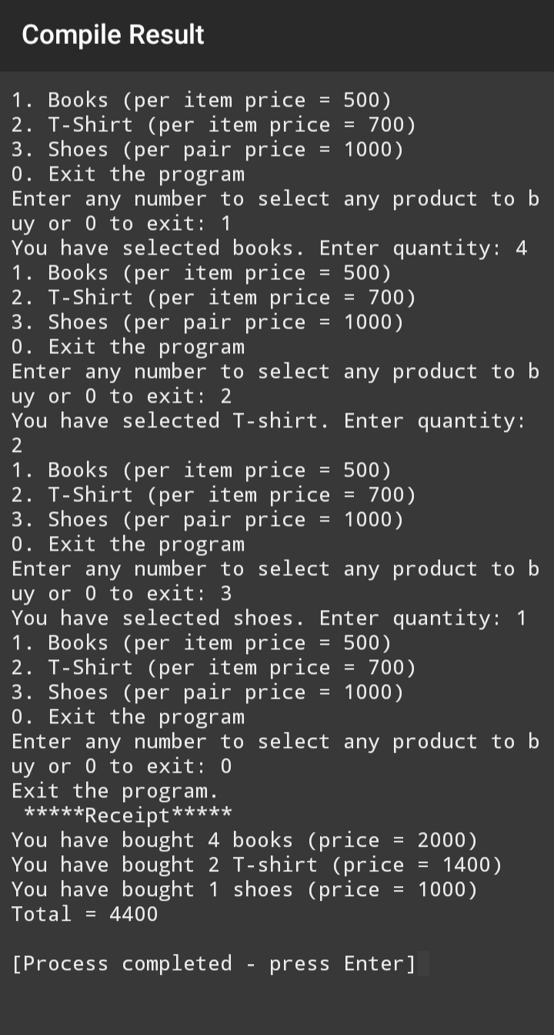
QUESTION N0 09: (CODE)
#include<iostream>
using namespace std;

int main()
{
for (char i=90;i<=90 && i>=65; i--)

cout <<i<<" ";
return 0;
}
QUESTION N0 09: (OUTPUT)
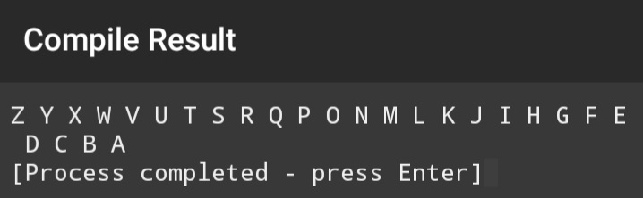
QUESTION N0 10: (CODE)
#include<iostream>
using namespace std;

int main()
{
for (char i=90;i<=90 && i>=65; i--){
if(i!=65 && i!=69 && i!=73 && i!=79 && i!=85)
cout <<i<<" ";
}
return 0;
}
QUESTION N0 10: (OUTPUT)
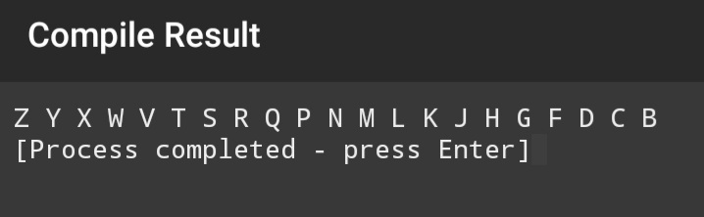
QUESTION N0 11: (CODE)
#include<iostream>
using namespace std;

int main()
{
float x,y,z=0,high(0),low(0);

cout << "Write the total number of integer\n";
cout<<"How many numbers do you have?>";

cin>>y;
if(y<0){
cout<<"Sorry, you have entered an invalid input."<<endl;
cout<<"Thank You."<<endl;}
else if(y==0){
cout<<"Opps, you don't have any number for me to process."<<endl;
cout<<"Thank You.";}
else
{
cout<<"Please enter a number_"<<1<<"-->";
cin>>z;

high=z;
low=z;

for(x=2; x<=y; x++){
cout<<"Please enter a number_"<<x<<"-->";
cin>>z;

if(z>=high){
high=z;
}
if(z<=low){
low=z;}
}

cout<<"The highest number is : "<<high<<endl;
cout<<"The lowest number is : "<<low<<endl;
cout<<"Thank You";
}
return 0;
}
QUESTION N0 11: (OUTPUT)
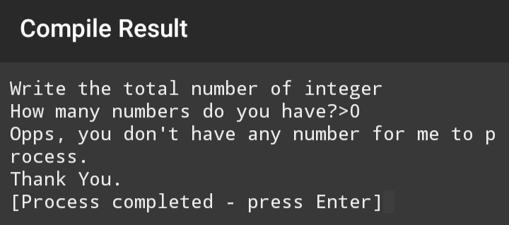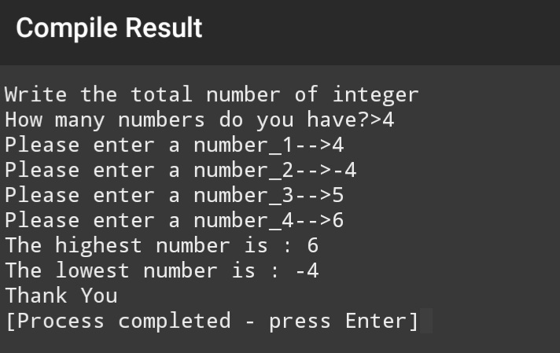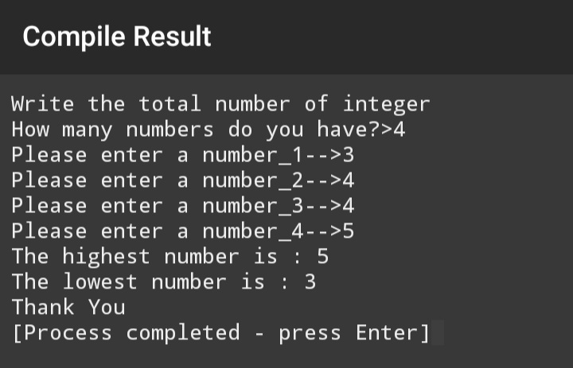
QUESTION N0 12: (CODE)
#include<iostream>
using namespace std;

int main()
{
int a,b,c;
cout<<"Enter any number for guessing:";
cin>>c;
for(b=1;a!=c; b++){
cout<<"Guess the number and Enter your guess:";
cin>>a;
if(a<c){
cout<<"The guessed number is smaller than actual number:\n";
}
else if(a>c){
cout<<"The guessed number is greater than actual number:\n";
}

else if(a==c){
cout<<"Congrats! You guessed it\n";
}
}
return 0;
}
QUESTION N0 12: (OUTPUT)
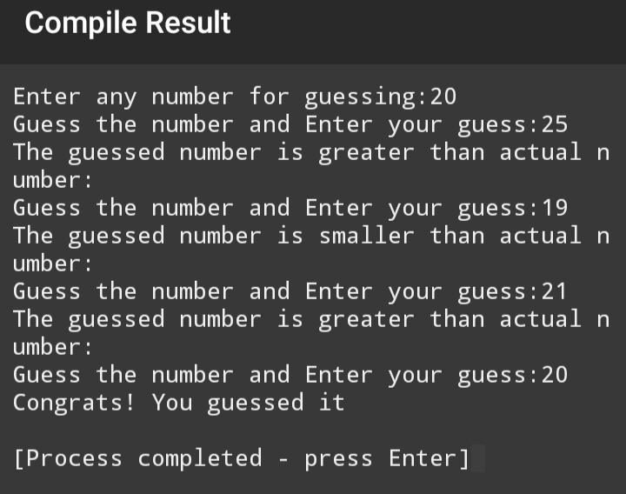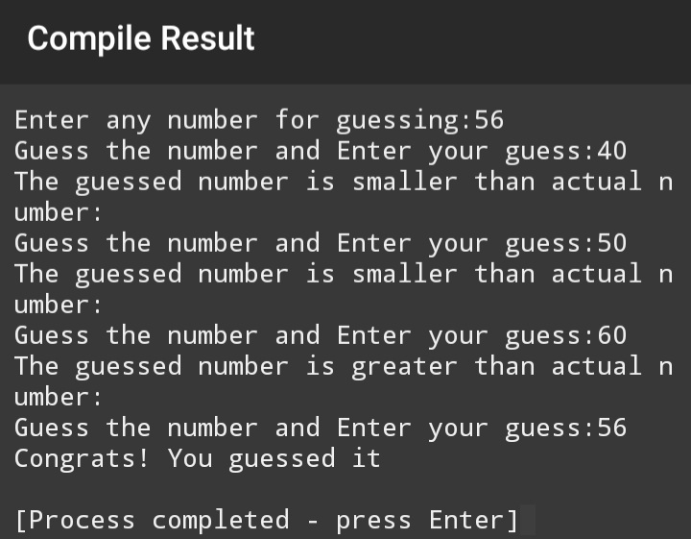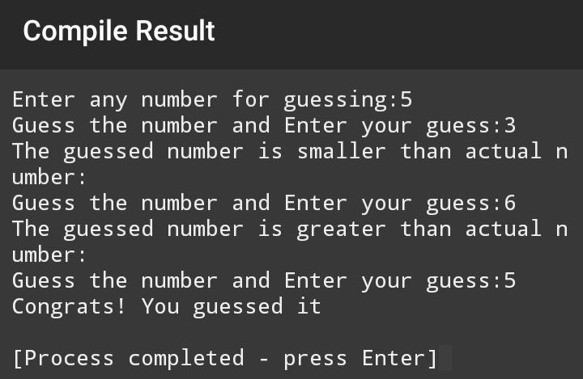
QUESTION N0 13: (CODE)
#include<iostream>
using namespace std;

int main()
{
int a,b,c;
cout<<"Enter the guess number from.(1 to 100) \n";
cin>>a;
cout<<"You have five attempts:\n";
for(b=1; b<=5 && c!=a; b++){
cout <<"Enter your guess number.\n";
cin>>c;
if(c<a){
cout<<"Your guessed number is smaller than actual.";
}
if(c>a) {
cout<<"Your guessed number is greater than actual.";
}
}
if(c==a){
cout<<"Congrats! You guessed it.";
}
else if(c!=a){
cout<<"Sorry! you guessed wrong values in all five attempts. the correct value is "<<a<<endl;
}
return 0;}
QUESTION N0 13: (OUTPUT)
